IJATB Vol. 4, No. 2, 2022

International Journal of Accounting, Taxation, and Business
https://journal.unsika.ac.id/index.php/IJATB

THE EFECT OF ENVIRONMENTAL MANAGEMENT ACCOUNTING PRACTICES
INTERVENING VARIABLE

Sekar Ayu Putri Permana ¹
Khairina Nur Izzaty ²

P r o g r a m S t u d i Accountancy​​​​​​​​ S T I E B a nk B P D J ate n g
ed.sekarayu@gmail.com izzaty33@gmail.com

Abstract
The phenomenon of pollution due to manufacturing waste that occurs in the Tenggang River, Genuk Kaligawe area, Semarang City, indicates that improvements in environmental management accounting practices in manufacturing companies in Semarang City need to be carried out. Apart from improving environmental performance, improving environmental management accounting practices can also improve company performance. Study This test influence environmental accounting practices with the performance of manufacturing companies with information systems as an intervening variable. The target population is 501 medium and large manufacturing companies with a sample size of 100 manufacturing companies that responded to the questionnaire. Respondents are middle-level managers of manufacturing companies. The research data uses primary data and uses the SMART PLS 3.0 analysis tool for data processing. The results of this research show that: (i) environmental management accounting practices are proven to have a positive and significant effect on the performance of manufacturing companies, (ii) environmental management accounting practices are proven to have a positive and significant effect on the performance of manufacturing companies. significant influence on information systems, (iii) information systems are proven to have a positive and significant influence on the performance of manufacturing companies, (iv) Proven mediation results, namely that information systems mediate positively and significantly between environmental management accounting practices on the performance of manufacturing companies
Key words: environmental management accounting practices, manufacturing company performance, information systems, manufacturing companies
Abstract
The phenomenon of pollution due to manufacturing waste occurs in the Tenggang river, Genuk Kaligawe, Semarang indicates that an increase in environmental management accounting practices in manufacturing companies in Semarang needs to be done. Besides being able to improve environmental performance, improving environmental management accounting practices can also improve company performance. This study examines the effect of environmental accounting practices on the performance of manufacturing companies with information systems as an intervening variable. The population is 501 medium and large manufacturing companies with a sample size of 100 manufacturing companies that responded to the questionnaire. Respondents are middle-level managers of manufacturing companies. The research data uses primary data and SMART PLS 3.0 analysis tool for data processing. The results of this study indicate that: (i) environmental management accounting practices have been shown to have a positive and significant effect on the performance of manufacturing companies, (ii) environmental management accounting practices have positive and significant impacts. Significant effect on information systems, (iii) information systems proved to have a positive and significant effect on the performance of manufacturing companies, (iv) the results of information system as mediating variable mediate positively and significantly between environmental management accounting practices on the performance of manufacturing companies.
Keyword: environmental management accounting pratices, performance of manufacturing companies, information system, manufacturing companies

1. INTRODUCTION
The phenomenon of environmental damage caused by the manufacturing sector is a problem that cannot be tolerated again. If left unchecked, various detrimental impacts such as global warming, natural disasters and ecosystem imbalances will emerge which can affect the sustainability of life in the future. Increasingly widespread environmental issues have made many people start to pay attention to whether the role played by manufacturing companies has a dangerous impact on the surrounding environment, thereby encouraging environmental damage.
Environmental management accounting (EMA) is applied as a complement to conventional accounting in providing information related to company environmental management (Fuzi, et al., 2019) . Christ & Burritt, ( 2013) stated that environmental problems and environmental accounting issues began to require the role of accounting practitioners and accountants since the 1980s. Adapting to the increasing level of environmental damage accompanied by increased public awareness to reduce the impact of environmental damage, the practice of environmental management accounting practice ( EMAP) is always developing and continues to be a relevant topic today.
Problems related to environmental damage caused by industrial activities are often found in Indonesia. A real example of environmental damage in Indonesia is the pollution that occurred in the city of Semarang. A survey conducted by the Central Java Province Central Statistics Agency in 2020 stated that Semarang City is the city that has the most medium and large manufacturing companies in Central Java . Quoted from the humas.jatengprov.go.id page, there are indications of environmental pollution in the Tenggang river, Genuk Kaligawe area, Semarang City. The river emits a lot of foam and smells bad. These indications are clear that this is waste originating from the manufacturing industry from the environment around the river. Sari et al., (2020) stated that environmental management accounting practices are a benchmark for environmental performance. This poor environmental performance shows that environmental management accounting practices in Semarang City have not been implemented optimally or require improvement.
From a managerial perspective, environmental management accounting consists of two combination factors, namely social activities that occur externally and activities related to internal business (Burritt & Schaltegger, 2010) . The topic of environmental management accounting is an answer to one of the company's responsibilities to follow up on social incentives that occur in outside the organization. Apart from creating companies that care about environmental safety, research conducted by Marcus & Fremeth, (2009) states that companies that openly implement environmental management accounting build a good reputation so that they can reduce the potential for companies to lose sales which results in decreased profits. This and supported by research conducted by Ningsih Wiwik Fitria & Rachmawati Ratih, (2017) and Aniela, (2012) shows that improving environmental management accounting practices not only has an impact on environmental performance, but can also have an impact on the company's financial performance. The implementation of environmental management accounting also increases the effectiveness and efficiency of company operations due to more detailed classification of environmental cost information (Ningsih Wiwik Fitria & Rachmawati Ratih, 2017) . Thus, improvements in environmental management accounting practices need to be carried out because they not only have an impact on improving environmental performance but also on improving company performance. This is in line with the nature of manufacturing companies which have challenges in continuing to improve company performance both in terms of finance and operations (Mohd Fuzi et al., 2019) .
To support this, an information system ( SI) is a solution that must be considered because it plays an important role in evaluation, monitoring and planning in managing environmental and company performance (Habidin et al., 2018) . Santoso, (2012) states that information processed from input produces output that is maximized as a basis for decision making to support the company's goals in gaining profits and sustaining the company's operations. Mohd Fuzi et al., (2019) stated that information systems can be used as an intervening variable because they can be related to environmental management accounting practices and company performance to improve environmental management accounting practices.
On this basis, this research intends to use information system variables in the influence between environmental accounting and manufacturing company performance by asking several research questions: ( i ) is​​​​​ there is a significant influence of environmental accounting and manufacturing company performance , ( ii ) what is there an influence between environmental accounting and information systems, ( iii ) is there a significant influence between information systems and manufacturing company performance, and ( iv ) is there a mediating effect from information systems on the influence of environmental accounting and manufacturing company performance.

2. LITERATUR REVIEW
2.1. Theoritical
Institutional Theory
Institutional theory discusses how an organization's structure and activities are formed under the coercion of an institution such as the government, bodies operating in the professional sphere, and the environment surrounding the organization or company. (Zuriana et al., 2015) . This theory is based on an organization or company that needs external legitimacy so that the organization or company can survive and is worthy of support. Reporting from the diction.id website, the environment around a company or organization demands in two ways, namely: (i) demands that force a company or organization to work effectively and efficiently in carrying out the company's or organization's activities, (ii) demands that originate from social and culture of society so that companies or organizations must comply with the rules that apply to social life such as values, norms, rules and beliefs. (DiMaggio & Powell, 1983) grouped three dimensions of institutional pressure, namely: (i) legal pressure ( coercive pressures ), (ii) imitation of other companies or organizations ( mimetic pressures ), and (iii) cultural pressures ( normative pressures ). Legal pressure explains that the government or body authorized to make regulations can intervene in the activities carried out by the company through changes to applicable regulations. Imitation pressure from other companies is a response from companies regarding proven techniques or something that rival companies do when faced with uncertain situations. Cultural pressure states that various types of activities of each individual, group, or leader of an organization or company determine how the conditions of each member work (DiMaggio & Powell, 1983) .
Environmental Management Accounting Practices
The activities of manufacturing companies are considered to have many benefits for society. Apart from producing products that are needed daily, manufacturing companies also play a role in absorbing labor, thereby reducing the unemployment rate. However, behind this mutually beneficial relationship , there is a dilemma where companies have the potential to produce hazardous waste and have a major impact on environmental damage. Because of that's a lot company start implement accountancy environmental management .
Environmental management accounting (EMA) is an accounting practice that identifies and measures information related to the environment to support the decision-making process (UNDSD., 2000) . Ningsih Wiwik Fitria & Rachmawati Ratih, (2017) added that environmental management accounting is used by companies to measure the effectiveness of resource use for environmental protection activities. Apart from influencing the effectiveness of cost use, this is also a form of preventive action and avoidance of the company's impact on the environment.
The information presented in the application of environmental management accounting is the disclosure of physical information on the use, flow and final destination of resources, water and raw materials including waste. Other information presented is related to financial information such as environmental costs, profits and savings. Environmental management accounting practices play an important role because they can support better operating procedures. (Sari et al., 2020)
Practice environmental management accounting or Environmental Management Accounting Practice (EMAP) supports information related to the environment that companies, especially manufacturing types, can use in improving and evaluating company performance (Mohd Fuzi et al., 2019) . The construct of environmental management accounting practices is summarized by Mohd Fuzi et al., (2019) as: (i) environmental costs, (ii) environmental regulations, (iii) environmental safety, (iv) management commitment, and (v) consumer focus. Even though it has been implemented by manufacturing companies in Indonesia, environmental management accounting practices are considered less effective or require improvement (Agustia, 2010) .

Company performance
Apart from paying attention to environmental impacts, a company will continue to operate if it has good performance. Zaleha, Rasid, & Isa, nd, (2014) stated that company performance or organizational performance (OPM) is a condition where the company can meet predetermined targets. Company performance is not only measured from the financial side, but also from the non-financial side (Hutahayan, 2020) . Several studies conducted by Habidin et al., (2018); Mohd Fuzi et al., (2019); Spencer, Adams, & Yapa, (2013) use operational dimensions as the non-financial and financial side to measure company performance. In manufacturing companies, financial dimensions are used to measure and evaluate the company's financial problems. On the other hand, the operational dimension is very important as a basis for measuring production, costs and manufacturing processes (Mohd Fuzi et al., 2019) .

Information Systems
Information systems or information systems (IS) are systems applied to companies that carry out data processing activities to produce output in the form of information that can be used for internal and external purposes. (Mohd Fuzi et al., 2019) . The output from the use of information systems in manufacturing companies is very important because it plays a role in planning, controlling, evaluating and continuous improvement so that the company can continue to develop and sustain itself. (Sutabri, 2012) . In manufacturing companies, information systems also play a role in managing resource information related to the environment.

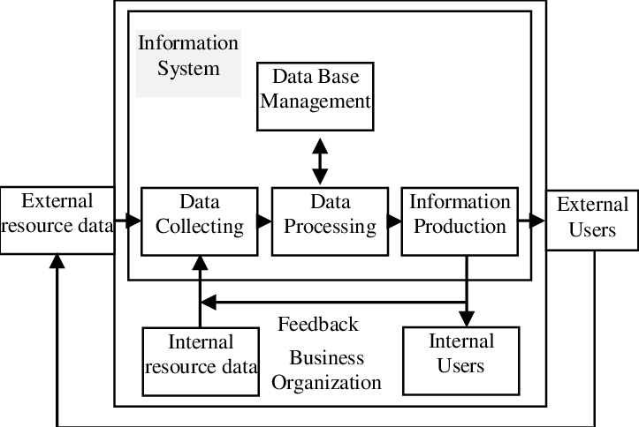
Figure 1 : General model of information systems
( https://www.researchgate.net/figure/General-Model-for-Accounting-Information-Systems-Data-Resources-These-are-data_fig1_254014898 )

The application of information systems in the environmental management of manufacturing companies is an unavoidable need considering how fast information related to the environment is developing. The dimensions used in Mohd Fuzi et al., (2019)' s research regarding information system connecting variables are technology and process. The use of information systems is expected to be implemented as a tool to increase the efficiency and effectiveness of environmental management accounting practices which are considered to have been implemented but are less effective as seen from the large amount of uncontrolled environmental pollution caused by the manufacturing industry in Indonesia.

2.2. Hypothesis
2.2. 1 Environmental Management Accounting Practices and Manufacturing Company Performance
Aniela, ( 2012) and Zulhaimi, ( 2015) stated that environmental management accounting practices have a beneficial role for manufacturing companies in Indonesia in improving company performance. This statement is supported by the research results of Mohd Fuzi et al., (2019); Sari et al., (2020) regarding the influence of environmental management accounting practices and company performance which has a positive and significant relationship. Based on this description, the hypothesis of the relationship between the two variables can be concluded as follows:
H1. Environmental Management Accounting Practices have a positive and significant effect on Manufacturing Company Performance .

2.2.2. Environmental Management Accounting Practices and Information Systems
In industries, especially those engaged in manufacturing, the application of information systems can provide support from companies to improve environmental management accounting practices (Mohd Fuzi et al., 2019) . This is because in information systems there is technology that supports the processing of information related to environmental information. Research conducted by Mohd Fuzi et al., (2019) discusses the influence of environmental management accounting practices and information systems and shows a positive and significant relationship regarding these two variables. Therefore, it can be concluded that the hypothesis from the variable relationship is as follows:
H2. Environmental Management Accounting Practices have a positive and significant effect on Information Systems.

2.2.3 . Information Systems and Manufacturing Company Performance
With an information system, companies will be able to easily make more accurate decisions. Company managers will utilize the output of the information system for decision making in planning and monitoring the running of the company in order to create company performance targets (Hailu, 2014) . Kehinde and Yusuf (2012) in Hailu, (2014) stated that an organization or company will not be able to survive without an information system.
Research conducted by Guzmán, Fóster, Ramírez-Correa, Grandón, & Alfaro-Perez, (2018); Hailu, (2014) shows positive results on the influence of information systems and company performance. The hypothesis from the research can be concluded as follows:
H3. Information Systems have a positive and significant effect on Manufacturing Company Performance .

2.2.4. The mediating effect of Information Systems in the Relationship between Environmental Management Accounting Practices and Manufacturing Company Performance
Mohd Fuzi et al., ( 2019) has conducted research involving 395 manufacturing companies in Malaysia which seeks the indirect influence of information systems on the relationship between environmental management accounting practices and company performance. The results show that the role of information systems is proven to mediate the influence of environmental management accounting practice variables and company performance. This research states that the implementation of information systems can improve the quality of decision making which has an impact on improving financial management accounting practices and company performance (Mohd Fuzi et al., 2019) . Based on this, it can be concluded that the hypothesis of the relationship between the three variables is as follows:
H4. There is influence positive, significant , and not direct between Environmental Management Accounting , Information Systems and Company Performance Manufacture

2.2. Research Model
Based on the hypothesis that has been determined, the research method is described as follows
Gambar 2: Kerangka Model Penelitian
Kinerja Perusahaan Manufakrur
H3
H2
H1
Praktik Akuntansi Manajemen Lingkungan
Sistem Informasi

H4

3. METHODOLOGY
3.1 Types of Research
The main objective of this research is to find the relationship between environmental management accounting practices and company performance and information systems as intervening variables . This research is a quantitative analysis type research. Quantitative analysis is used because it requires data measurement and generalization of results from the sample to the population. In addition, research that uses quantitative analysis can propose hypotheses, as temporary answers to research questions (Suliyanto, 2017) .

3.2 Operational Definition and Variable Measurement
This research uses one independent variable, one dependent variable, and one intervening variable.
3.2.1. Independent Variable ( Dependent Variable )
Independent variables are variables that are thought to independently influence the dependent variable (Supomo, 1999). This research uses the variable environmental management accounting practices as a variable that is thought to influence Manufacturing Company Performance as the dependent variable. Environmental management accounting practices are accounting practices that identify and measure information related to the environment to support the decision-making process (UNDS., 2000) .

Table 3.1. Constructs and Variable Question Items
Environmental Management Accounting Practices.
Variable | Construct | Item code | Question Items | Source  Instrument
Accounting Practice  Environmental Management | Environmental Costs | BL1 | Identify environmentally related costs. | (Ferreira et al., 2010)
 |  | BL2 | Allocate environmentally related costs to production processes.
 |  | BL3 | Allocate environmentally related costs to the products produced.
 |  | BL4 | Using environmental related cost accounts.
 |  | BL5 | Improve management of environmentally related costs.
 | Environmental Regulation | RL1 | Aware of environmental issues. | (Alkisher, 2018)
 |  | RL2 | Comply with environmental regulations.
 |  | RL3 | Oversee environmental regulations.
 |  | RL4 | Comply with environmental procedures.
 |  | RL5 | Pledged to implement environmental regulations.
 | Environmental Security | KL1 | Consider environmental safety. | (Hanim et al., 2016)
 |  | KL2 | Increase environmental safety awareness.
 |  | KL3 | Comply with environmental safety.
 |  | KL4 | Provide security equipment.
 |  | KL5 | Understand environmental procedures .
 | Management Commitment | KM1 | Employees pay attention to environmental issues. | (Alkisher, 2018)
 |  | KM2 | Employees comply with environmental activities.
 |  | KM3 | Employees support environmental management.
 |  | KM4 | Employees support environmental programs.
 |  | KM5 | Employees participate in decision making regarding the environment.
 | Consumer Focus | FK1 | The organization is determined to create consumer satisfaction. | (Ferreira et al., 2010)
 |  | FK2 | Organizations are determined to provide value to consumers.
 |  | FK3 | The organization meets consumer criteria.
 |  | FK4 | The organization supports environmentally friendly practices for consumers.
 |  | FK5 | Consumers provide feedback on quality and delivery performance.

3.2.2. Dependent Variable ( Independent Variable )
The dependent variable is a variable that is influenced by the independent variable (Supomo, 1999). This research uses manufacturing company performance variables because they are thought to be influenced by environmental management accounting practices as an independent variable. Manufacturing company performance is a condition where the company can meet predetermined targets (Mohd Fuzi et al., 2019) . In this research, the performance of manufacturing companies is measured in 2020.

Table 3. 2. Constructs and Variable Question Items
Manufacturing Company Performance.
Variable | Construct | Code  items | Question Items | Instrument source
Manufacturing Company Performance | Financial performance | KK1 | Increased sales growth. | (Purnendu Mandal, 2016)
 |  | KK2 | Increased profit growth.
 |  | KK3 | Increased operating income.
 |  | KK4 | Increased return on investment.
 |  | KK5 | Reduced costs.
 | Operational Performance | KO1 | Increased product quality. | (Muganda et al., 2014)
 |  | KO2 | Improved operational processes.
 |  | KO3 | Increased operational efficiency.
 |  | KO4 | The number of goods delivered on time increases.
 |  | KO5 | Reduced operational costs.

3.2.3. Intervening Variable ( Intervening Variable )
Intervening variables are variables that influence the relationship between the independent variable and the dependent variable into an indirect relationship. This is because the intervening variable interrupts the independent variable and the dependent variable so that the independent variable does not directly influence the dependent variable (Sugiyono, 2007). In this research, information systems are an intervening variable that influences the indirect relationship between environmental management accounting practices and manufacturing company performance. An information system is a system applied to companies that engage in data processing so as to produce output in the form of information that can be used for internal and external purposes (Mohd Fuzi et al., 2019).

Table 3. 3. Constructs and Question Items Information System Variables.
Variable | Construct | code | Question Items | Instrument source
Information Systems | Technology | TK1 | Providing information technology within the company. | (Dwyer et al., 2013)
 |  | TK2 | Providing data collection within the company.
 |  | TK3 | Providing data processing within the company.
 |  | TK4 | Applying database software in the company.
 |  | TK5 | Supporting information technology for decision making.
 | Process | PR1 | The company pays attention to the production process. | (Adebanjo, D., Teh, P.-L., & Ahmed, 2016)
 |  | PR2 | The company oversees the operations process.
 |  | PR3 | The company evaluates the production process.
 |  | PR4 | The company provides process development.
 |  | PR5 | Companies improve process efficiency.

3.3 Data Types and Sources
Primary data is used in this research because the data was collected by researchers from the first source (Suliyanto, 2017) . This data was obtained through a questionnaire which was created in an online format using Google Form and sent directly via email to manufacturing companies in Semarang City to support ease in obtaining data. The research instrument was measured using a Likert measurement scale . The Likert scale is a measuring tool that provides several questions to measure an individual's behavior by responding to several choice points provided in each question item (Likert, 1932) .

3.4 Data Collection Methods
The data collection method used in this research is the questionnaire method. A questionnaire is a data collection method where a list or instrument of questions is created by the researcher and then distributed to target respondents. This research uses a Likert scale as a tool to measure the relationship between each variable. Likert scale. Initially, the Likert scale only consisted of five response points, namely strongly agree, agree, undecided, disagree, and strongly disagree (Likert, 1932) . As time goes by, the Likert scale measurement continues to develop until it reaches 15 response points. Budiaji, (2013) stated that the sensitivity and linearity of the number of response points from five to seven response points are the same. Apart from that, Budiaji, (2013) added that the stability of the response points increases at response points 7,8,9,10. However, Hofmans et al. (2007) suggested using seven response points because seven response points are preferred by respondents.
In accordance with the research instrument from Mohd Fuzi et al., (2019) which has been mentioned in table 1, table 2, and table 3 , the analysis of the three variables, namely environmental management accounting practices, information systems, and company performance uses a Likert scale with seven points. response to obtain research data from respondents. For the variable environmental management accounting practices and information systems, the details are point (1) which is "very low" to point (7) which is "very high". Meanwhile, the company performance variable has details, namely point (1) "strongly disagree", point (2) "disagree", point (3) "somewhat disagree", point (4) "neutral", point (5) " somewhat agree”, point (6) “agree”, and point (7) “strongly agree”.

3.5 Population and Sample
Population is an area consisting of subjects or objects that have conditions and characteristics determined by researchers to produce a conclusion. A survey conducted by the Central Java Province Central Statistics Agency noted that in 2020 there were 501 medium and large scale manufacturing companies in the city of Semarang. Therefore, the population determined in this research is 501 manufacturing companies in Semarang City. There are 24 business field categories grouped by BPS Central Java Province. The various business categories of manufacturing companies are written in table 3.4.

Table 3.4. Manufacturing Company Business Field Category
No | Business Field Category | No | Business Field Category
1 | Food | 13 | Rubber, goods made of rubber and plastic
2 | Drink | 14 | Non-metallic minerals
3 | Tobacco processing | 15 | Base metal
4 | Textiles | 16 | Metal items, not machines and equipment
5 | Apparel | 17 | Computers, electronics and optics
6 | Leather, leather goods and footwear | 18 | Electrical equipment
7 | Wood | 19 | Machinery and equipment
8 | Paper and paper goods | 20 | Motor vehicles, trailers and semi-trailers
9 | Printing and reproduction of recorded media | 21 | Other means of transportation
10 | Products from coal and petroleum refining | 22 | Furniture
11 | Chemicals and goods made from chemicals | 23 | Other processing
12 | Pharmaceuticals, chemical medicinal products and traditional medicines | 24 | Machinery and Equipment repair and installation services
Source: https://www.bps.go.id/subject/9/industri-besar-dan-sedang.html

The research was carried out in Semarang City because of the lack of environmental management accounting practices that occur in Semarang City . This can be seen from several examples of cases that occur in the surrounding environment, such as river pollution due to factory waste that occurs in the Tenggang River, Genuk Kaligawe area, Semarang City. Research conducted by Sari et al., ( 2020) targeted operational managers from 86 manufacturing companies as respondents. This is because operational managers have the responsibility to report company performance to the company's marketing director. Therefore, the respondents in this study were middle level managers at manufacturing companies in Semarang City.
The sample is part of the population that meets the criteria for data to be measured in the research. To take samples as a basis for research measurements, the cencus sampling technique was used on the population, namely all manufacturing companies in Semarang City, Central Java. Cencus sampling is a sample determination method where researchers use research samples from all questionnaires returned from the total sent to the population. To determine the minimum sample, Hair et al, (2011) recommend a minimum of 100-500 respondents to measure the relationship between hypotheses when using SEM ( Structural equation model ) analysis.

3.6 Data Analysis Methods
According to Sugiyono (2015) quantitative research methods are research methods that are based on samples of positivism philosophy with the aim of testing predetermined hypotheses. This is achieved by researching a certain population or sample, collecting data to be processed using research instruments, then carrying out quantitative or statistical data analysis. The quantitative research carried out in this research uses an explanatory design, namely using an explanatory research object of study . Explanatory research uses methods to explain causal relationships between variables that have been determined through hypothesis testing (Mulyadi, 2013) . Explanatory research uses a sample as the basis for testing, then generalizes it to the population of that sample.
Suliyanto (2017) stated that explanatory or causal analysis can use the help of the Smart PLS application for data processing. The model in Smart PLS consists of two stages, namely the measurement model ( outer model ) and the structural model ( inner model ).

3.6.1. Measurement Model ( Outer Model )
The measurement model or outer model defines how each indicator is related to its latent variable with the aim of knowing the validity and reliability of the indicators that form the determined research variables. In accordance with this definition, the outer model carries out several tests, namely validity and reliability tests. In research, it is important to test the quality of data in order to determine the consistency and accuracy of data measurements so that it can produce quality research (Yusup et al., 2018) . According to Indriantoro and Supomo (1999), there are two ways to evaluate the quality of data. These concepts are validity testing and reliability testing.

3.6.1.1. Validity test
Validity test is a test with the aim of measuring whether a questionnaire is valid or not. A questionnaire will be said to be valid if the questionnaire can reveal data originating from variables accurately and in accordance with the actual situation (Yusup et al., 2018) . Validity tests have two types, namely convergent validity and discriminant validity .

3.6.1.1.1. Convergent Validity
The convergent validity value is the loading factor value on the latent variable with its indicators. To test the validity of each indicator on a variable, the individual reflexive measure is said to be high if it correlates > 0.7 with the construct to be measured, meaning that the indicator is declared valid in measuring the construct created. For the development stage, the measurement scale for loading values > 0.5 is considered sufficient (Ghozali, I., & Latan, 2015) .

3.6.1.1.2. Discriminant Validity (Discriminant Validity)
Discriminant validity determines if two measurements that should not be correlated are truly uncorrelated. Discriminant validity compares the AVE of a particular construct with the correlation between that construct and other constructs (Awang, 2016) . If the Average Variance Extruded (AVE) value is > 0.5 then it is said to be valid (Ghozali, I., & Latan, 2015)

3.6.1.2. Reliability Test
Apart from validity tests, Smart PLS also carries out reliability tests to prove the accuracy, consistency and precision of the instrument in measuring something (Ghozali, I., & Latan, 2015) . Reliability based testing to ensure that the instrument used is a consistent, stable and dependable instrument . To measure the validity of a construct, you can use two methods, namely composite reliability and Cronbach's alpha .

3.6.1.2.1. Composite Reliability
Composite Reliability is part of the reliability test which is used to test whether a certain variable indicator is consistent and reliable. (Ghozali & Latan, 2015) stated that the reliability value is said to be reliable if the composite reliability value is >0.7. Even so, the composite reliability value of 0.6 is still acceptable.

3.6.1.2.2. Cronbach's Alpha
Cronbach's Alpha value can strengthen composite reliability in reliability testing. The Cronbach's Alpha value achieved is >0.7 so that a variable can be said to be reliable (Ghozali & Latan, 2015)

3.6.1.3. Multicollinearity Test
The multicollinearity test is used to test whether in the regression model a correlation is found between the independent variables which is used to detect the presence or absence of multicollinearity. If the VIF is 3.5-5, it is stated that there is no multicollinearity (Ghozali & Latan, 2015) . If the VIF exceeds the predetermined value, it can drastically affect the outer model testing.

3.6.2. Structural Model ( Inner Model)
A structural model or inner model is a model that connects latent variables by predicting explanatory relationships between predetermined variables. (Solling Hamid & M Anwar, 2019) .

3.6.2.1. Virtue Test ( Goodness of Fit )
The goodness of fit test tests whether the sample data matches the distribution of a certain population. In other words, this test explains whether the sample in the research represents the actual population. In this research there are 4 types of virtue tests, namely coefficient of determination, Q-square predictive revelance, Effect size test , normal fit index.

3.6.2.1.1. Coefficient of Determination
The coefficient of determination determines how much ability the independent variable has in explaining the variance of the dependent variable. The coefficient of determination is obtained from squaring the correlation coefficient (R).

3.6.2.1.2. Q-Square predictive popularity
Q-Square predictive relevance for a construct model measures how well the observed values are generated by the model and its parameter estimates. A QSquare value > 0 indicates the model has predictive relevance. The Q-Square quantity has values in the range 0 < Q2 < 1.

3.6.2.1.3. Effect Size Test (f2)
Apart from assessing whether or not there is a significant relationship between variables, a researcher should also assess the magnitude of the influence between variables with Effect Size or f-square. An fsquare value of 0.02 is small, 0.15 is medium, and a value of 0.35 is large. Values less than 0.02 can be ignored or considered to have no effect.

3.6.2.1.4. Normal Fit Index (NFI)
One of the first fit measures proposed in the SEM literature was the Normal Fit Index (NFI) by Bentler and Bonett (1980). It calculates the Chi² value of the proposed model and compares it with a meaningful benchmark. Since the Chi² value of the proposed model itself does not provide enough information to assess model fit, NFI uses the Chi² value of the null model, as a benchmark. NFI is then defined as 1 minus the Chi² values of the proposed model divided by the Chi² values of the null model. As a result, NFI produces a value between 0 and 1. If the NFI value is > 0.1 or higher then the model will be found to be good or acceptable. The closer the NFI is to 1, the better the fit. NFI values above 0.9 usually represent acceptable fit.

3.6.2.2. Hypothesis testing
3.6.2.2.1. T test ( t-test )
The t test aims to determine the magnitude of the influence of the independent variable on the dependent variable partially. To see the significance of the relationship between variables, the T-test analysis of the path coefficient ( PathCoefficient ) is used . The positive influence and significance level of each variable can be achieved if the T-Statistic > 1.96. This value means that the exogenous variable has a significant influence on the endogenous variable. If the T-Statistic < 1.96, then the exogenous variable has no significant influence on the endogenous variable.
3.6.2.2.2. Direct Influence ( Direct Effect )
effect analysis is carried out to test whether there is a direct influence from the hypothesis of an exogenous variable on an endogenous variable. If the value of the path coefficient (Path Coefficient) is positive, then the influence of a variable on it is in the same direction, if the value of an exogenous variable increases/rises, then the value of the endogenous variable also increases/rises. If the value of the path coefficient (Path Coefficient) is negative, then the influence of a variable on it is in the opposite direction, if the value of an exogenous variable increases/rises, then the value of the endogenous variable decreases. If the Probability/Significance (P-Value) value is <0.05 (5%), then it is significant. If the P-Values value is > 0.05 (5%), then it is not significant.

3.6.2.2.3. Indirect Effect
Indirect effect analysis is useful for testing the hypothesis of the indirect influence of an influencing variable (exogenous) on the influenced variable (endogenous) which is mediated/mediated by an intervening variable (mediator variable). If the P-Values value is <0.05 (5%), then it is significant, meaning that the mediator variable mediates the influence of an exogenous variable on an endogenous variable. In other words, the effect is indirect. If the P-Values value is > 0.05 (5%), then it is not significant, meaning that the mediator variable does not mediate the influence of an exogenous variable on an endogenous variable. In other words, the effect is direct.
4. Analysis and Discussion Results
Respondents are operational level managers who understand the company's operations. In the questionnaire, the researcher made sure not to publish the names of manufacturing companies that were willing to fill out the online questionnaire with the aim of maintaining company confidentiality and making respondents more objective in answering the questions. Of all the emails sent to all companies in Semarang City, there were 152 respondents who filled out the Google Form questionnaire . When conducting validity and reliability tests, the results showed that there were several question items that were not valid and reliable. Sample reduction was carried out until validity and reliability were achieved in accordance with the requirements. To achieve this, the sample was reduced from 152 samples to 100 samples.
4.1. Demographic Description
In this research, respondents came from 100 medium and large scale manufacturing companies in Semarang City, Central Java Province. In the previous section, it was explained that there are 24 categories of business fields according to a survey conducted by Central Java Province BPS on medium and large scale manufacturing companies. In this study, respondents who filled out the questionnaire came from manufacturing companies with 19 different business categories. Details of business field categories from the 100 samples are summarized in Figure 4.1.

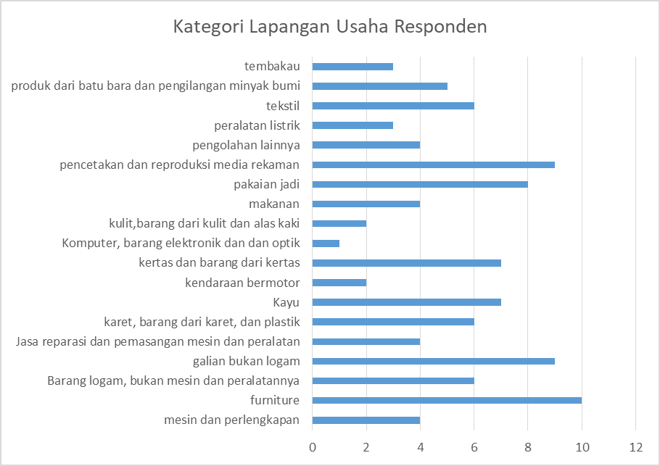
Figure 4.1. Respondent's Business Field Category

4.2. Data analysis
4.2.1. Partial Least Square (PLS) Model Scheme
In this research, hypothesis testing uses the Partial Least Square (PLS) analysis technique with the smartPLS program. The proposed model scheme is seen after the model has undergone outer model testing. Scheme can seen in figure 4.2.
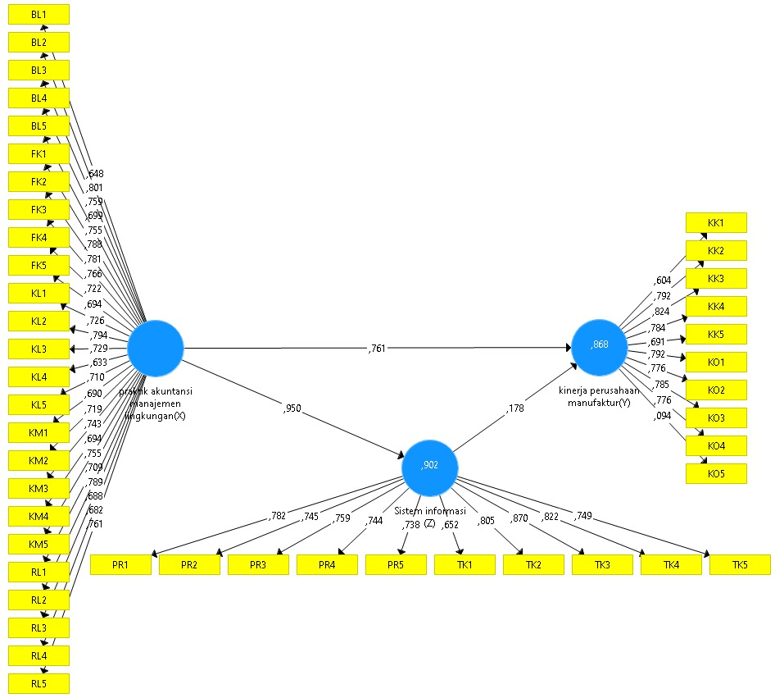

Figure 4.2. Outer Model

4.2.2. Evaluation of Model Measurements ( Outer Model)
The outer model shows how the variables are manifest or observed variable represents the latent variable to be measured. In this model analysis, it specifies the relationship between latent variables and their indicators.

4.2.2.1 Validity Test Analysis
In conducting research, this test is a measurement of whether each question presented in the form of a questionnaire is able to represent the variables studied. When using Smart PLS, validity measurements are carried out in 2 ways and the results of the analysis that have been carried out are convergent validity and discriminant validity.

4.2.2.1.1. Convergent Validity
In assessing each construct, the construct assessment is seen from convergent validity. Convergent Validity is measured using outer loading and AVE ( Average Variance Extracted ) parameters. An individual reflexive measure is said to be correlated if the value is more than 0.7 with the construct to be measured. However, for research in the early stages of development, a measurement scale with a loading factor value of 0.5 to 0.6 is considered sufficient (Ghozali and Latan, 2015). After passing one test, there was one question item from the KO construct that did not have a value of >0.6 with a value of 0.094, namely question item KO5. Therefore, item KO5 was removed because it did not meet the requirements.

Table 4.1 . Deleted question item
items | SI(Z) | KPM (Y) | PAML (X)
KO5 |  | ,094
Source: Primary Analysis Data, 2021

The second test was carried out after deleting the KO5 question items with a total of 44 question items tested, resulting in a convergent validity table with all question items that met the requirements.
Table 4.2. Convergent Validity
no | items | PAML (X) | SI(Z) | KPM (Y) | no | items | PAML (X) | SI(Z) | KPM (Y)
1 | BL1 | ,648 |  |  | 23 | KM3 | ,743
2 | BL2 | ,801 |  |  | 24 | KM4 | ,694
3 | BL3 | ,759 |  |  | 25 | KM5 | ,755
4 | BL4 | ,699 |  |  | 26 | KO1 |  |  | ,791
5 | BL5 | ,755 |  |  | 27 | KO2 |  |  | ,775
6 | FK1 | ,788 |  |  | 28 | KO3 |  |  | ,786
7 | FK2 | ,781 |  |  | 29 | KO4 |  |  | ,775
8 | FK3 | ,766 |  |  | 30 | PR1 |  | ,782
9 | FK4 | ,722 |  |  | 31 | PR2 |  | ,745
10 | FK5 | ,694 |  |  | 32 | PR3 |  | ,759
11 | KK1 |  |  | ,606 | 33 | PR4 |  | ,744
12 | KK2 |  |  | ,791 | 34 | PR5 |  | ,738
13 | KK3 |  |  | ,824 | 35 | RL1 | ,709
14 | KK4 |  |  | ,785 | 36 | RL2 | ,789
15 | KK5 |  |  | ,691 | 37 | RL3 | ,688
16 | KL1 | ,726 |  |  | 38 | RL4 | ,682
17 | KL2 | ,794 |  |  | 39 | RL5 | ,761
18 | KL3 | ,729 |  |  | 40 | TK1 |  | ,652
19 | KL4 | ,633 |  |  | 41 | TK2 |  | ,805
20 | KL5 | ,710 |  |  | 42 | TK3 |  | ,870
21 | KM1 | ,690 |  |  | 43 | TK4 |  | ,822
22 | KM2 | ,719 |  |  | 44 | TK5 |  | ,749
Source: Primary Analysis Data, 2021
The findings in Table 4.4 above show that the variables used in this research in almost every question representing each variable have a loading factor value of > 0.6. So it can be stated that the questions representing each variable meet the requirements for research.
4.2.2.1.2. Discriminant Validity
Discriminant validity is measured using cross loading values and average variance extracted (AVE) values. The results of the findings in this test using average variance extracted (AVE) show that the AVE value produced by each variable used is greater than 0.5, so it can be said to meet the requirements .
Table 4.3. Average Variance Extracted (AVE) Value
variable | Average Variance Extracted (AVE)
PAML (X) | ,534
SI(Z) | ,591
KPM (Y) | ,579
Source: Primary Analysis Data, 2021
Based on the table presented above, it can be seen that the AVE value of all the variables tested is > 0.5. This shows that each variable has good discriminant validity .

4.2.2.2. Reliability Test Analysis
Reliability measurement shows how accurate the respondent's answers are in the variables used to determine whether the respondent is consistent in answering the questions under study. In this measurement, there are 2 types of methods used in research, namely composite reliability and Cronbach's alpha .

4.2.2.2.1. Composite Reliability
Composite reliability is the part used to test the reliability value of variable indicators. A construct is said to be reliable if the composite reliability value is > 0.7, which has high reliability, although 0.6 is still acceptable.
Table 4.4. Composite Reliability
Variable | Composite Reliability
PAML (X) | ,966
SI(Z) | ,935
KPM (Y) | ,925
Source: Primary Analysis Data, 2021
composite reliability value produced by all variables exceeds the value of 0.7 so that all variables are reliable.
4.2.2.2.2. Cronbach's Alpha
The reliability test with composite reliability can be strengthened by using the Cronbach's Alpha value as a variable assessment criterion. If the Cronbach's Alpha value for each variable is > 0.7 then it is said to be reliable.
Table 4.5. Cronbach's Alpha
Variable | Cronbach's Alpha
PAML (X) | ,963
SI(Z) | ,922
KPM (Y) | ,908
Source: Primary Analysis Data, 2021
Thus, these results can indicate that each research variable has met the Cronbach's Alpha value requirements , so it can be concluded that all variables have a high level of reliability.

4.2.2.3. Multicollinearity Test Analysis
This test is to see whether each independent variable has a correlation between the independent variables or not. The applicable criteria in the multicollinearity test is if the VIF value is <3.5-5. The first test to look for multicollinearity in the research was carried out with the results that there was quite a lot of multicollinearity in the inner VIF research. This can be seen in the table of results of the first test of the multicollinearity test.

Table 4.6 . First Multicollinearity Test
Variable | SI(Z) | KPM (Y)
PAML (X) | 1,000 | 10,227
SI(Z) |  | 10,227
Source: Primary Analysis Data, 2021
From the table, it can be seen that there are multicollinearity values that exceed 5, even more than 10. This indicates that there is quite a lot of multicollinearity in each variable. This can influence the results of searching for direct and indirect effects of each variable. To reduce the level of multicollinearity, there are several ways, one of which is deleting several question items that make the multicollinearity value unnatural. Therefore, several question items were deleted to produce acceptable multicollinearity values for continuing the next measurement.
Table 4.7. Deleted items
NO | Deleted items
1 | BL1
2 | KL2
3 | KM4
4 | KO5
5 | PR1
6 | PR4
7 | TK1
8 | TK2
9 | TK3
10 | TK4
Source: Primary Analysis Data, 2021

Table 4.8. Second Multicollinearity Test
Variable | SI(Z) | KPM (Y)
PAML (X) | 1,000 | 4,730
SI(Z) |  | 4,730
Source: Primary Analysis Data, 2021
The second measurement for the multicollinearity test shows that the VIF has a value according to the requirements, namely <3.5 to <5. This can be seen from table 4.8. Even though there was a reduction in question items, there were no significant changes to the validity and reliability testing that had been carried out previously. Because there is no multicollinearity, further testing can be carried out to find the influence of each variable.
4.2.3. Structural Model Analysis ( Inner Model)
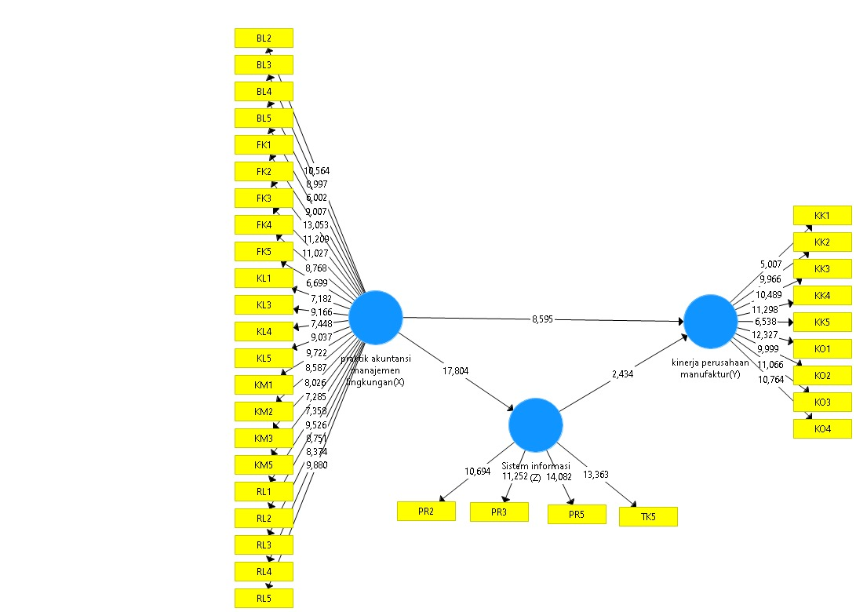
Figure 4.3. Inner Model
The inner model shows the strength of estimates between latent variables or constructs. This section explains the results of the goodness of fit test and hypothesis testing.
4.2.3.1. Model Feasibility Analysis ( Goodness of Fit)
This test is to determine whether the model formed is suitable for research or not by looking at the research results .
Table 4.9. R Square Results
Variable | R Square | R Square Adjusted
SI(Z) | ,789 | ,786
KPM (Y) | ,865 | ,862
Source: Primary Analysis Data, 2021
The R-Square table above is used to see the influence of environmental management accounting practice variables on information systems and the influence of environmental management accounting practice variables on manufacturing company performance. Based on the data in the table above, it is known that the influence of environmental management accounting practice variables on the information system is 0.789 or 78.9% and the influence of environmental management accounting practice variables on the performance of manufacturing companies is 0.865 or 86.5%.
Then the goodness of fit assessment uses Q-square with the calculation:
Q square = 1 – [(1-R21) x (1-R22)]
= 1-[(1-0 .865 ) x (1-0 .789 )]
= 1 – ( 0.135 x 0.211 )
= 1 – 0.028
= 0.972
This means that the results of this analysis show that the Q square value is 0.972, meaning that the level of model diversity shown by the independent variable in explaining the dependent variable is 0.972 or 97% and the remaining 0.028 or 2.8% is still influenced by other factors. Thus, from these results, this research model can be stated to have good goodness of fit.
Table 4.10. NFI Analysis Results
 | Saturated Model | Estimated Model
NFI | ,726 | ,726
Source: Primary Analysis Data, 2021
the model fit indicators show that if the NFI value is > 0.1 or higher, the model can be said to be much better.
4.2.3.2. Hypothesis Test Analysis
4.2.3.2.1. Direct Effect Testing
Based on this data, analysis is carried out, the results can be used to answer the hypothesis of this research. To see the results of hypothesis testing in this research, you can do it by looking at the results of the t statistics and P values . This hypothesis can be said to be accepted if the P value is <0.05. Meanwhile, to get a significant effect, it can be seen from the t statistic results >1.96. This research also has a direct and indirect influence on each variable because it contains independent variables, dependent variables and intervening variables. The results of processing the direct influence hypothesis can be seen in the path coefficient table in SmartPLS bootstrapping. The test results can be seen through the bootstrapping test shown in table 4.11.

Table 4.11. Direct Influence
Hypothesis | Influence Between Variables | Original Sample (O) | T Statistics (|O/STDEV|) | P Values
H1 | PAML(X) -> KPM (Y) | ,743 | 8,595 | ,000
H2 | PAML(X) -> SI(Z) | ,888 | 17,804 | ,000
H3 | SI (Z) -> KPM (Y) | ,206 | 2,434 | ,015
Source: Primary Analysis Data, 2021
It can be seen from the P values produced by the bootstrapping test , the path coefficient results show that h1, namely that there is a positive and direct influence of Environmental Management Accounting Practices (X) on Manufacturing Company Performance (Y) is considered significant because it has a t statistic value of >1.96, amounting to 8.595 and accepted because it has a P value <0.05 of 0. Likewise, h2, where there is a positive and direct relationship between environmental management accounting practices (X) and information systems (Z), is considered significant with a t statistic value of >1.96 of 17.804 and is accepted because it has a P value of <0.05 of 0. The same as The two previous hypotheses, h3 also state that there is a direct and significant positive relationship between the information system (Z) and the performance of manufacturing companies (Y) because it has a t statistic value >1.96 of 2.434 and a P value <0.05, namely 0.015.
4.2.3.2.2. Indirect Effect Testing
This analysis is more about explaining the results of significant influences indirectly or using mediation. The analysis results obtained are displayed in table 4.12.
Table 4.12. Indirect Influence
Hypothesis | Influence Between Variables | Original Sample (O) | T Statistics (|O/STDEV|) | P Values
H4 | PAML (X) -> SI (Z) -> KPM (Y) | ,183 | 2,460 | ,014
Source: Primary Analysis Data, 2021
Based on data that has been processed through indirect tests or specific indirect effects , it can be said that h4 which states that there is a significant positive and indirect relationship between environmental management accounting practices (X), information systems (Z), and manufacturing company performance (Y) is accepted. because it has a t statistic value > 1.96 of 2.460 and a p value of <0.05 of 0.014.
4.3. Discussion
4.3.1. The Influence of Environmental Management Accounting Practices and Manufacturing Company Performance
The results of the first hypothesis in the tests that had been carried out previously were accepted. These results are in line with research by Aniela, (2012); Mohd Fuzi et al., (2019); Sari et al., (2020); and Zulhaimi, (2015) who stated that environmental management accounting practices have a positive and significant effect on the performance of manufacturing companies. The results of this research mean that improving environmental management accounting practices can also improve the performance of manufacturing companies. This statement supports institutional theory where companies have a tendency to seek legitimacy from external parties to maintain the company (Meyer and Rowan, 1977). Marcus & Fremeth, (2009) stated that companies that openly implement environmental management accounting build a good reputation so that they can reduce the potential for the company to lose sales which results in a decline in the company's financial performance . This is also in accordance with the statement by Ningsih Wiwik Fitria & Rachmawati Ratih, (2017) that environmental management accounting practices can be useful in measuring the effectiveness of resource use which can have an effect on improving financial performance.

4.3.2. The Influence of Environmental Management Accounting Practices with Information Systems
The results of the second hypothesis in the tests that had been carried out previously were accepted. The results of this research are in line with research conducted by Mohd Fuzi et al., (2019) which produced a positive and significant influence between environmental management accounting practice variables and information systems. The results of this research mean that improving environmental management accounting practices can also improve Information Systems. This supports the statement of Mohd Fuzi et al., (2019) where the implementation of environmental management accounting requires processing information related to the environment. Information systems play a role in processing this information.

4.3.3. The Influence of Information Systems and Manufacturing Company Performance
The results of the third hypothesis regarding the relationship between the two variables after going through data processing are accepted. The results of this research are in line with research conducted by Guzmán et al., (2018) and Hailu, (2014) which produced a positive and significant influence between these two variables. The results of this research mean that improving Information Systems can also improve Manufacturing Company Performance. As stated in Hailu's research (2014) , companies will have difficulty surviving without an information system. The output from the information system can be utilized to improve the performance of manufacturing companies.

4.3.4. The Influence of Environmental Management Accounting Practices, Information Systems, and Manufacturing Company Performance
In the data processing results shown by the indirect effect testing table ( indirect effect ) shows that there is a positive and significant relationship between environmental management accounting practices, information systems, and manufacturing company performance. The results of this research mean that improving environmental management accounting practices can also improve information systems which then have an impact on increasing the performance of manufacturing companies. The results of this research are in line with research conducted by Mohd Fuzi et al., (2019) that information systems are proven to mediate the relationship between environmental management accounting practices and the performance of manufacturing companies.
5. Conclusion
5.1. Conclusion
Based on research regarding the relationship between environmental management accounting practices and the performance of manufacturing companies with information systems as an intervening variable, conclusions can be drawn namely; (i) Environmental Management Accounting Practices are proven to have a positive and significant effect on Manufacturing Company Performance, (ii) Environmental Management Accounting Practices are proven to have a positive and significant effect on Information Systems, (iii) Information Systems are proven to have a positive and significant effect on Manufacturing Company Performance, (iv) ) Proven mediation results, namely that the information system mediates positively and significantly between Environmental Management Accounting Practices on Manufacturing Company Performance.
5.2. Limitations
This research has many limitations, including filling out the questionnaire online so there is no direct supervision from the researcher. Apart from that, the sample selection was deemed inadequate and the population was only limited to the city of Semarang.

5.3. Suggestion
For further research, it is hoped that more samples will be used for maximum results. It is also recommended to expand the selection of variables so that further research can be more accurate.

Reference
Indriantoro, Nur, and Bambang Supomo, 1999, Research and Business Methodology, Yogyakarta: BPFE Yogyakarta
Sugiyono, MPP (2007). Quantitative Approach. Qualitative, and R&D, Bandung: Alphabet
Adebanjo, D., Teh, P.-L., & Ahmed, P. (2016). Article information : The impact of external pressure and sustainable management practices on manufacturing performance and environmental outcomes .
Augustia, D. (2010). Environmental Cost Reporting as a Tool for Decision Making Related to Environmental Management. ACCRUAL: Journal of Accounting , 1 (2), 190. https://doi.org/10.26740/jaj.v1n2.p190-214
Alkisher, A. (2018). Overview of Drivers behind Environmental Management Accounting (EMA) Overview of Drivers behind . November .
Aniela, Y. (2012). The Role of Environmental Accounting in Improving Environmental Performance and Company Financial Performance. Accounting Student Scientific Periodical , 1 (1), 15–19. http://journal.wima.ac.id/index.php/BIMA/article/view/24
Awang, Z. (2016). Re: What is discriminant validity? https://www.researchgate.net/post/What_is_discriminant_validity/575fac5796b7e44e830d6aee/citation/download.
Central Java Province Central Statistics Agency. (2020). DIRECTORY OF LARGE AND MEDIUM MANUFACTURING INDUSTRIES OF CENTRAL JAVA PROVINCE 2020 .
Budiaji, W. (2013). Skala Pengukuran dan Jumlah Respon Skala Likert (The Measurement Scale and The Number of Responses in Likert Scale). Ilmu Pertanian Dan Perikanan, 2(2), 127–133. http://umbidharma.org/jipp
Burritt, R. L., & Schaltegger, S. (2010). Sustainability accounting and reporting: Fad or trend? Accounting, Auditing & Accountability Journal. https://doi.org/10.1108/09513571011080144
Christ, K. L., & Burritt, R. L. (2013). Environmental management accounting: The significance of contingent variables for adoption. Journal of Cleaner Production. https://doi.org/10.1016/j.jclepro.2012.10.007
DiMaggio, P. J., & Powell, W. W. (1983). The Iron Cage Revisited: Institutional Isomorphism and Collective Rationality in Organizational Fields. In American Sociological Review (Vol. 48, Issue 2, p. 147). https://doi.org/10.2307/2095101
Dwyer, R., Lamond, D., Molina-azorín, J. F., Claver-cortés, E., & López-gamero, M. D. (2013). Environmental protection and financial performance : an empirical analysis in Wales. https://doi.org/10.1108/IJOPM-11-2010-0374
Ferreira, A., Moulang, C., & Hendro, B. (2010). Environmental management accounting and innovation: An exploratory analysis. Accounting, Auditing and Accountability Journal, 23(7), 920–948. https://doi.org/10.1108/09513571011080180
Ghozali, I., & Latan, H. (2015). Partial least squares: Konsep, teknik, dan aplikasi menggunakan program smart PLS 3.0 (2nd ed.). In Semarang: Universitas Dipone-goro Semarang.
Ghozali, I., & Latan, H. (2015). Partial Least Squares, concepts, techniques and applications using the Smartpls 3.0 program for empirical research. Semarang: UNDIP Publishing Agency.
Guzmán, S. A., Fóster, P. F., Ramírez-Correa, P., Grandón, E. E., & Alfaro-Perez, J. (2018). Information Systems and their Effect on Organizational Performance: An Inquiry into Job Satisfaction and Commitment in Higher Education Institutions. Journal of Information Systems Engineering & Management, 3(4). https://doi.org/10.20897/jisem/3937
Habidin, N. F., Hashim, S., Fuzi, N. M., & Salleh, M. I. (2018). Total productive maintenance, kaizen event, and performance. International Journal of Quality and Reliability Management, 35(9), 1853–1867. https://doi.org/10.1108/IJQRM-11-2017-0234
Hailu, T. (2014). The Impact of Information System ( IS ) on Organziational Performace : With Special Refernce to Ethio-Telecom Southern Region , Hawassa. 6(37), 331–339.
Hair, J. F., Ringle, C. M., & Sarstedt, M. (2011). PLS-SEM: Indeed a silver bullet. Journal of Marketing Theory and Practice. https://doi.org/10.2753/MTP1069-6679190202
Hanim, F., Mohamed, B., Zulkifle, Z. B., Binti, S. Z., & Kadir, A. (2016). Safety And Health Practices And Injury Management In Manufacturing Industry. Procedia Economics and Finance, 35(October 2015), 705–712. https://doi.org/10.1016/S2212-5671(16)00088-5
Hutahayan, B. (2020). The mediating role of human capital and management accounting information system in the relationship between innovation strategy and internal process performance and the impact on corporate financial performance. 27(4), 1289–1318. https://doi.org/10.1108/BIJ-02-2018-0034
likert. (1932). “Technique for the Measurement of Attitudes, A.” Encyclopedia of Research Design. https://doi.org/10.4135/9781412961288.n454
Marcus, A. A., & Fremeth, A. R. (2009). Green management matters regardless. Academy of Management Perspectives. https://doi.org/10.5465/amp.2009.43479261
Mohd Fuzi, N., Habidin, N. F., Janudin, S. E., Ong, S. Y. Y., & Ku Bahador, K. M. (2019). Environmental management accounting practices and organizational performance: the mediating effect of information system. Measuring Business Excellence, 23(4), 411–425. https://doi.org/10.1108/MBE-12-2018-0109
Muganda, N., John, O., Roy, K., Ochara, N. M., Kandiri, J., & Johnson, R. (2014). technology projects in Africa Influence processes of implementation effectiveness in challenged information technology projects in Africa. https://doi.org/10.1108/ITP-09-2013-0167
Mulyadi, M. (2013). Quantitative and Qualitative Research and Basic Rationale for Combining Them. Journal of Communication and Media Studies , 15 (1), 128. https://doi.org/10.31445/jskm.2011.150106
Ningsih Wiwik Fitria, & Rachmawati Ratih. (2017). Implementation of green accounting in improving company performance | ningsih | JABE (Journal of Applied Business and Economics) . 4 (2), 149–158. https://journal.lppmunindra.ac.id/index.php/JABE/article/view/2142/1630
Purnendu Mandal, K. B. (2016). Industrial Management & Data Systems .
Santoso, HF (2012). Environmental Accounting Review of Management Accounting Information Systems for Environmental Costs. Journal of Accounting , 12 (2), 635–654.
Sari, RN, Pratadina, A., Anugerah, R., Kamaliah, K., & Sanusi, ZM (2020). Effect of environmental management accounting practices on organizational performance: role of process innovation as a mediating variable. Business Process Management Journal . https://doi.org/10.1108/BPMJ-06-2020-0264
Solling Hamid, R., & M Anwar, S. (2019). Variant-based Structural Equation Modeling (SEM) (Abiratno, S. Nurdiyanti, & A. Diniati Raksanaga (eds.)).
Spencer, S.Y., Adams, C., & Yapa, P.W.S. (2013). The mediating effects of the adoption of an environmental information system on top management's commitment and environmental performance. Sustainability Accounting, Management and Policy Journal , 4 (1), 75–102. https://doi.org/10.1108/SAMPJ-10-2011-0030
Suliyanto. (2017). Quantitative Training Method Training. Journal of Chemical Information and Modeling , 5 (2), 223–232.
Sutabri, T. (2012). Information Systems Concept. UPI Journal of Educational Administration , 3 (1), 248.
United Nations Division for Sustainable Development. (2000). Improving governments' role in the promotion of environmental managerial accounting. In United Nations publication .
Yusup, F., Studi, P., Biology, T., Islam, U., & Antasari, N. (2018). VALIDITY AND RELIABILITY TEST . 7 (1), 17–23.
Zaleha, S., Rasid, A., & Isa, CR (nd). Management accounting systems, enterprise risk management and organizational performance in financial institutions . https://doi.org/10.1108/ARA-03-2013-0022
Zulhaimi, H. (2015). The Effect of Implementing Green Accounting on Company Performance. Journal of Accounting and Finance Research , 3 (1), 603. https://doi.org/10.17509/jrak.v3i1.6607
Zuriana, C., Jamil, M., Mohamed, R., Muhammad, F., & Ali, A. (2015). Environmental management accounting practices in small medium manufacturing firms. Procedia - Social and Behavioral Sciences, 172, 619–626. https://doi.org/10.1016/j.sbspro.2015.01.411

